BREATHE
Personalized Air Quality Health Risk System — Project Overview & Status

Overview
A single AQI number can't tell you how badly a specific person will actually be affected. A healthy 25-year-old and a 70-year-old with asthma breathing the exact same polluted air face very different real health risk — the raw AQI treats them identically. That's the core problem BREATHE is built to solve.
It works in three layers. First, low-cost outdoor sensors report live pollution levels across a neighborhood, so the system knows the actual air quality at a person's specific location, not just a citywide average. Second, that reading is combined with the person's own health profile — age, existing conditions, how long they spend outdoors — to produce a risk score tailored to them, not a generic one. Third, a smartwatch adds a live signal from the person's own body: if their heart rate spikes or blood oxygen dips while they're out in poor air, that's real-time evidence the pollution is affecting them right now, so the score adjusts to reflect that.
Current deployment scope: an outdoor neighborhood-scale sensor mesh, not an indoor space. This was a deliberate decision — the reasoning is explained under Planned Progress below.

Current Progress
- Backend — FastAPI service built and live-tested: /health, /ingest, /predict, /vitals endpoints, backed by SQLite (sensors, readings, vitals, user_baselines tables).
- Spatial layer — IDW spatial interpolation (power p=2, configurable trust radius, default 500m) implemented and verified against three real test cases: exact sensor match, multi-sensor blend, and out-of-radius fallback.
- Codebase audit — Existing repo checked against the original project disclosure; concrete gaps identified and a build roadmap agreed on (this document reflects the current, corrected plan).
- Biometric path decided — Smartwatch integration will go through the Fitbit Web API, polled from the backend — no native mobile app needed for the prototype. Built so it can later be swapped for Android Health Connect without changing anything else in the pipeline.
- NHANES data — The two most recent public health-survey cycles (2015-16, 2017-18) identified and downloaded for building the personal-susceptibility model.

Planned Progress — What's Changing and Why
Two significant course-corrections were made after digging into the details. Both are explained here so it's clear what's kept, what's changing, and the reasoning.
- Kept unchanged — The AQI Forecaster (predicts near-future pollution trend) and the overall PHRS scoring formula (adds up pollution exposure, then multiplies by personal vulnerability). Both remain structurally as originally designed.
- Changing — NHANES scope. The original plan linked each survey respondent to their county's pollution history to train the susceptibility model. That data is not publicly downloadable — U.S. privacy rules restrict it to a formal research-access process taking months, which doesn't fit the timeline. Fix: the model instead learns general personal susceptibility (from age, existing conditions, BMI, smoking) without needing location data. The location-specific pollution response is supplied separately, from a published study (below) — so the final score still accounts for both, just assembled from two sources instead of one combined dataset.
- Changing — calibration source. The project's original reference dataset for tuning the formula's weights turned out to be synthetic and not tied to any real city — confirmed by the codebase's own internal notes. Fix: switch to a 2025 published study that measured real health-risk categories for Delhi and Varanasi at known pollution levels. This is used as an answer key — the model's output is checked against it, and weights are adjusted until they agree, giving the formula a real-world grounding it didn't have before.
- Changing — deployment scope. Indoor use was considered, but indoor air depends on ventilation, cooking, and AC — dynamics the available training data (city-wide outdoor pollution history) knows nothing about. An outdoor neighborhood mesh doesn't have this mismatch, since local outdoor pollution genuinely follows the same city-wide patterns the model already learned. Fix: prototype is scoped to outdoor/neighborhood deployment.

Pipeline Architecture
The system runs as two separate pipelines: one-time offline training, and per-request runtime inference. Keeping them separate is what makes the app fast — all the heavy checking against real-world data happens once, ahead of time, not on every prediction.

1. Training pipeline (offline, one-time)
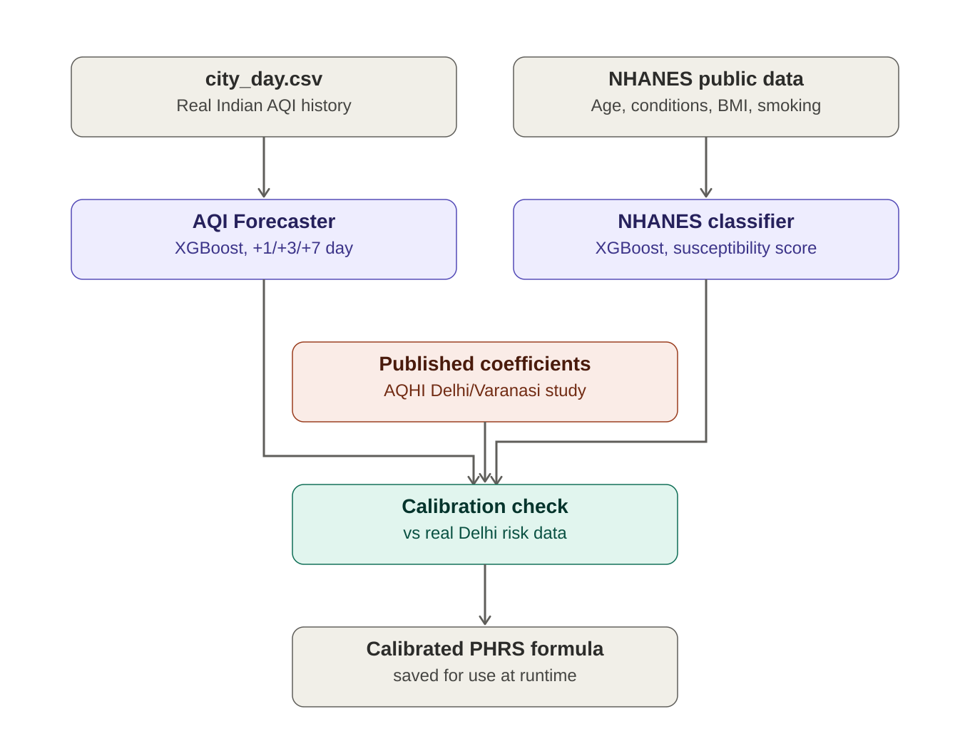

2. Runtime pipeline (per prediction request)
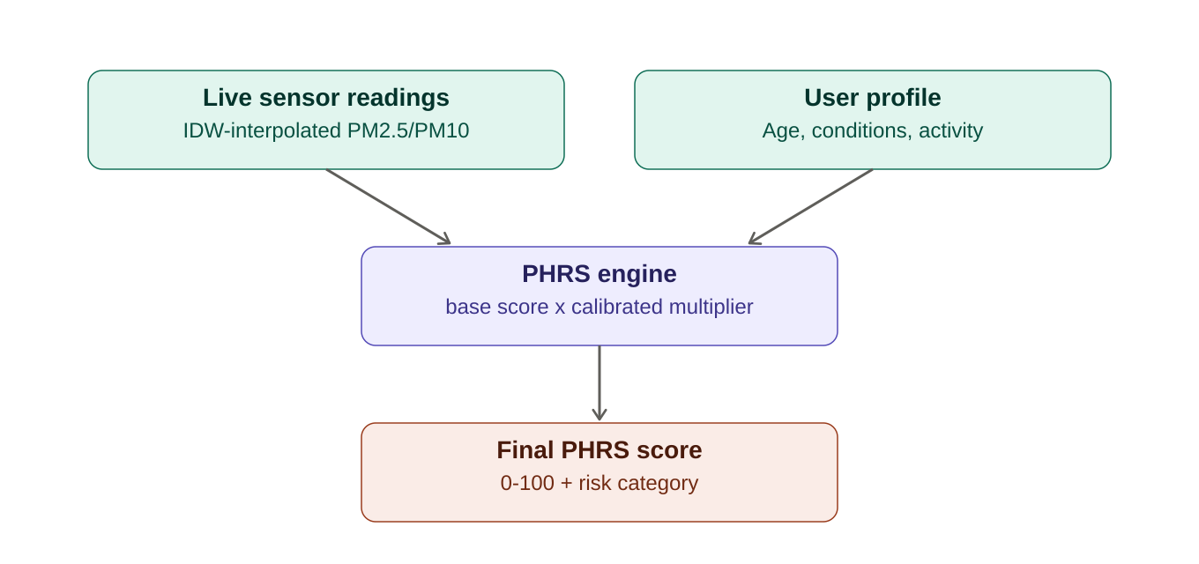

Planned Work
- NHANES classifier — Train on the 2-cycle subset and wire its output into the PHRS engine, replacing the current hardcoded condition-weight table.
- PHRS calibration — Run known scenarios through the formula, compare against the published Delhi/Varanasi risk categories, and tune weights until they agree.
- Hardware — Flash one real ESP32 with PMS5003 + DHT22, wired to /ingest; pair with 2-3 simulated nodes so the IDW mesh has enough points to visibly blend for a demo.
- Biometrics — Register a Fitbit developer app, implement backend polling for heart rate + SpO2, feed into /vitals, apply the biometric risk modifier.
- AQI Forecaster — Its original training data file is missing from the repo and needs to be sourced or regenerated before retraining.
- Frontend — Build a minimal single-page demo showing live score, category, and sensor map.
- Integration — Full end-to-end test with real hardware and a real watch; prepare a scripted fallback in case live hardware misbehaves during the demo.

Known Limitations (stated honestly)
- NHANES sample is small (roughly 5,000-6,000 people after merging both cycles) and has no geographic linkage — it predicts general personal susceptibility, not a location-specific pollution exposure history.
- PHRS coefficients are literature-informed engineering estimates, calibrated against one published study — not independently peer-validated for this exact formula.
- The AQI Forecaster is trained on city-level data. Its temporal trend patterns transfer reasonably to an outdoor neighborhood mesh (the chosen deployment scope) but would not have transferred to an indoor use case.

